
ALLIANCE UNIVERSITY
Alliance School of Advanced Computing

Student Name: Gaurav Agarwal
Register Number: PROV/ASAC/MCA/7/26/018
Project Name: Project Phoenix – AI-Powered Student Project & Career Management System

ACADEMIC YEAR: 2026-2028

Department of Computer Applications

Program - Master of Computer Applications
Semester 1

ACKNOWLEDGEMENT
I would like to express my sincere gratitude to everyone who supported and guided me throughout the successful completion of this project.
I am thankful to my Project Guide for providing valuable guidance, suggestions, encouragement, and continuous support throughout the development of this project. I also express my gratitude to the faculty members and my institution for providing the necessary resources and a supportive learning environment.
I would also like to thank my friends and classmates for their cooperation and support during the completion of this project. Finally, I am deeply grateful to my family for their constant encouragement, motivation, and support.
I sincerely thank everyone who contributed directly or indirectly to the successful completion of this project.
Student Name:
Gaurav Agarwal

Register Number:
PROV/ASAC/MCA/7/26/018

Project Title:
Project Phoenix – AI-Powered Student Project & Career Management System

Signature of Student

Signature of Faculty & Project Guide

Project Faculty & Project Guide Name: Oleti Durga Bravish
1. Abstract
Project Phoenix – AI-Powered Student Project & Career Management System is a unified academic platform designed to connect project assignment, student submission, evaluation, analytics, skill development, and career guidance in one workflow. The project addresses three major challenges identified in the project concept: project work being scattered across platforms, feedback being delayed or inconsistent, and students being uncertain about suitable career pathways.
The system provides role-based workspaces for students, teachers, and parents. Teachers can create project assignments, define requirements and rubrics, review submissions, provide final marks and feedback, and view class-level insights. Students can view assigned work, submit projects, monitor progress, build portfolios, earn points and badges, and explore career pathways. Parents can view linked student progress and participate in PTM-oriented career discussions.
An AI-assisted evaluation layer provides a preliminary assessment of project quality, completeness, accuracy, and areas for improvement. The final grade remains under teacher review. The dataset used in this project contains 1,000 student-project records and supports analysis of project performance, skills, submission behaviour, AI feedback, career interests, and recommended careers.
The resulting platform is intended as an academic prototype that combines project management with data-driven student development rather than treating grades as the only measure of progress.

2. Introduction
Project-based learning gives students an opportunity to apply classroom concepts to practical problems. However, when project assignment, submission, evaluation, feedback, and career guidance are handled separately, students may lose visibility of their progress and teachers may spend significant time organizing information.
The Project Phoenix concept proposes a connected learning journey. The project presentation describes a centralized hub for project assignment and management, AI-assisted evaluation, career exploration, gamification, portfolio development, and parent-teacher counselling. The workflow is designed around a human-in-the-loop model: AI performs an initial assessment while teachers provide contextual judgment and publish the final result.
The interface design organizes the system into separate student, teacher, and parent workspaces. Student navigation includes Dashboard, My Projects, Career Guidance, Portfolio, Leaderboard, and Messages. Teacher navigation includes Dashboard, Assignments, Evaluation Inbox, Class Insights, PTM Counselling, and Messages. Parent navigation includes Overview, Student Progress, PTM Counselling, Goals & Pathways, and Messages.

3. Problem Statement
The project is motivated by the following practical problems:
• Lack of centralization: project assignments and progress information may be distributed across different tools, making tracking difficult.
• Limited feedback: students may receive delayed or inconsistent feedback, reducing the usefulness of project work for learning.
• Career uncertainty: students may not clearly understand how their project skills relate to possible career paths.
• Disconnected evaluation: project submission, AI feedback, teacher grading, and student reflection can become separate activities.
• Limited progress visibility: students, teachers, and parents need different views of the same learning journey.
• Weak evidence of skills: grades alone do not show the projects, competencies, feedback, and achievements a student has built.
The project presentation explicitly frames the original problem around lack of centralization, limited feedback, and career indecision.

4. Existing System
In a conventional academic workflow, project instructions may be shared through separate classroom or communication platforms, students submit files through another channel, teachers maintain marks separately, and career counselling may occur independently. Such a fragmented workflow makes it harder to connect a student's project activity with skill development and future goals.
Major limitations of the existing approach include:
• No single dashboard showing assignments, deadlines, submissions, feedback, and progress.
• Manual effort for teachers to organize submissions and compare student performance.
• Feedback may not be standardized across projects.
• Career guidance is often separated from evidence of actual project performance.
• Student portfolios and achievements may not be connected to teacher-reviewed work.
• Parents may receive only periodic grade information instead of a broader progress picture.
The Project Phoenix concept responds to these gaps through centralized project management, AI-assisted evaluation, career exploration, points, leaderboards, portfolios, and PTM counselling.

5. Proposed System
Project Phoenix proposes a role-based web platform that connects the complete project lifecycle. The core workflow is: teacher assignment → student submission → AI preliminary evaluation → teacher review → final grade and feedback → analytics, portfolio evidence, and career guidance.
5.1 Main Modules
Student Module: Dashboard, assigned projects, submission, progress tracking, portfolio, points/badges, leaderboard, career guidance, and messages.
Teacher Module: Assignment creation, transparent rubric definition, submission/evaluation inbox, project checking, marks and feedback, class insights, PTM counselling, and messages.
Parent Module: Student progress, reviewed results, goals and pathways, PTM counselling, and notifications.
Project Management: Project title, subject, class/group, skill level, due date, requirements, accepted file types, project links, and rubric-based assessment.
AI-Assisted Evaluation: Preliminary checks for completeness, accuracy, rubric alignment, strengths, and improvement suggestions. The AI result is not the final grade.
Career Guidance: Career exploration based on skills and interests, with suggested pathways and next skills to practice. Recommendations are guidance rather than guaranteed outcomes.
Gamification & Portfolio: Teacher-reviewed points, class leaderboard, badges, and a portfolio containing selected reviewed projects and demonstrated skills.
5.2 Project Workflow
1. Teacher creates an assignment with instructions, requirements, skill level, deadline, and assessment rubric.
2. Student views the assignment, works on the project, uploads the required files or project link, and submits the work.
3. The system performs a preliminary AI-oriented evaluation of completeness, accuracy, and rubric alignment.
4. The teacher opens the evaluation inbox, checks the original student work and AI observations, assigns final rubric scores, and adds feedback.
5. The published result becomes the student's final reviewed grade and contributes to points, portfolio evidence, analytics, and progress tracking.
6. Career guidance uses project and skill evidence together with stated interests to present exploratory recommendations.
The project presentation describes the same sequence as Teacher Assignment, Student Submission, AI Evaluation, and teacher-focused feedback. The detailed UI reference also states that AI scores are preliminary and teacher review determines the final grade.

6. About Dataset
The cleaned Project Phoenix dataset is a structured student-project assessment dataset. It contains 1,000 records and 21 columns. Each record links a student with demographic and education information, a project, competency scores, submission status, project score, points earned, AI feedback, career interest, and recommended career. The dataset therefore supports both academic-performance analysis and career-guidance analysis.
Dataset Property | Value
Records | 1,000 student-project records
Columns | 21
Unique Project IDs | 100
Project Subjects | 10
Cities | 10
Skill Levels | Beginner, Intermediate, Advanced
Education Levels | School, Higher Secondary, Undergraduate, Postgraduate
Submission Status | Submitted on time / not submitted on time
Assessment Areas | Programming, analytical, creativity, communication, problem solving, completeness, accuracy
Guidance Fields | AI feedback, career interest, recommended career

The dataset documentation describes the same structure: student identity and education attributes, project subject and skill level, seven scored competencies, submission status, project score, points earned, AI feedback, career interest, and recommended career.
6.1 Important Dataset Fields
Field Group | Fields | Purpose
Student | student_id, student_name, age, city, education_level | Identifies and profiles the learner.
Project | project_id, project_subject, skill_level | Describes the assigned project and expected level.
Competencies | programming_score, analytical_score, creativity_score, communication_score, problem_solving_score, completeness_score, accuracy_score | Measures project-related competencies.
Performance | submitted_on_time, project_score, points_earned | Tracks completion and achievement.
AI/Feedback | ai_feedback | Stores preliminary qualitative feedback.
Career | career_interest, recommended_career | Compares learner interest with recommended pathway.

6.2 Dataset Analysis
Analysis of the cleaned dataset shows an average project score of 69.79 and an average of 94.33 points earned. 808 records were marked as submitted on time, while 192 were not. Intermediate-level projects form the largest skill group with 458 records, followed by Beginner with 401 and Advanced with 141.
The most frequent project subjects are Business Analytics (110), Database (107), Cyber Security (105), Data Science (103), and UI/UX Design (103). The average competency scores are highest for completeness (77.30), followed by problem solving (67.08) and communication (65.01).
In the career recommendation field, UI/UX Designer is the most frequent recommendation with 277 records, followed by Product Manager with 213, Mobile App Developer with 117, Database Administrator with 107, and Data Analyst with 93.
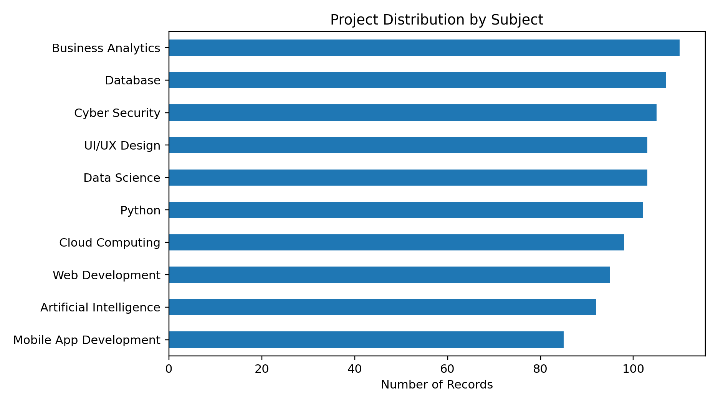
Figure 1. Distribution of student projects by subject
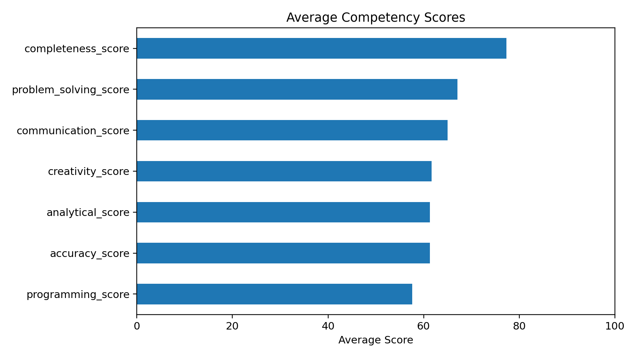
Figure 2. Average competency scores in the dataset
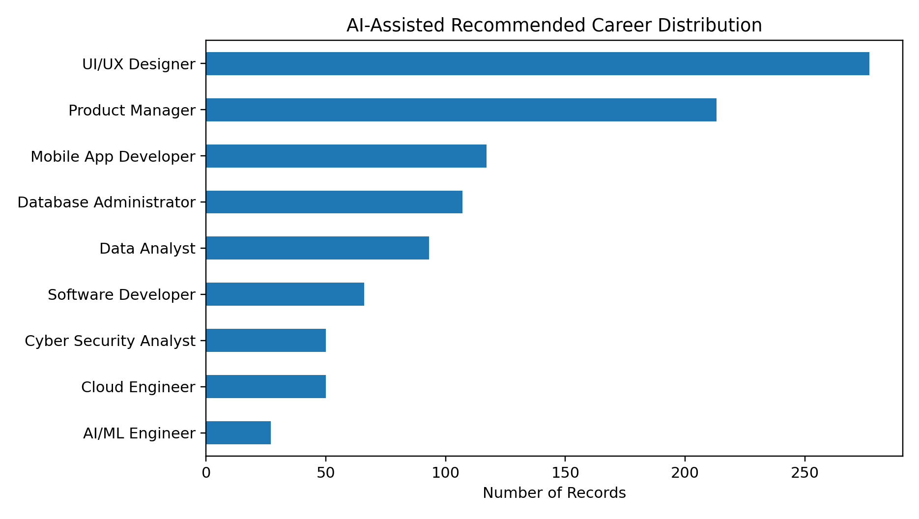
Figure 3. Distribution of AI-assisted recommended careers

7. Technologies Used
The project combines web technologies, application logic, structured data, and analytics. The following stack is suitable for the implemented Project Phoenix prototype and the dataset-driven dashboard workflow:
Technology / Tool | Role in Project
HTML5 | Structures the student, teacher, parent, assignment, evaluation, dashboard, and career-guidance pages.
CSS3 | Provides responsive layout, cards, tables, forms, navigation, status styles, and visual hierarchy.
JavaScript | Handles client-side interaction, form behaviour, dynamic UI updates, validation, and dashboard interactions.
Python / Flask | Provides application-side routing, business logic, data handling, and integration between the interface and stored project data.
Pandas | Supports dataset loading, cleaning, filtering, aggregation, and analytical preparation.
CSV Dataset | Stores the Project Phoenix student-project assessment data used by the analytics and recommendation views.
Power BI | Supports visual analysis of project performance, skill scores, submission behaviour, and career-related distributions.
Web Browser | Provides the execution environment for the responsive web interface.

The UI reference specifies a responsive desktop-first interface with a 12-column grid and role-specific navigation, together with reusable cards, tables, forms, project status indicators, and dashboard patterns.

8. Data Flow Diagram
The Level-1 DFD below represents the major information flow in Project Phoenix. Students and teachers interact with the application for project work and evaluation, parents access progress and counselling information, the application stores project/user data, and the AI/analytics layer produces evaluation and career/performance insights.
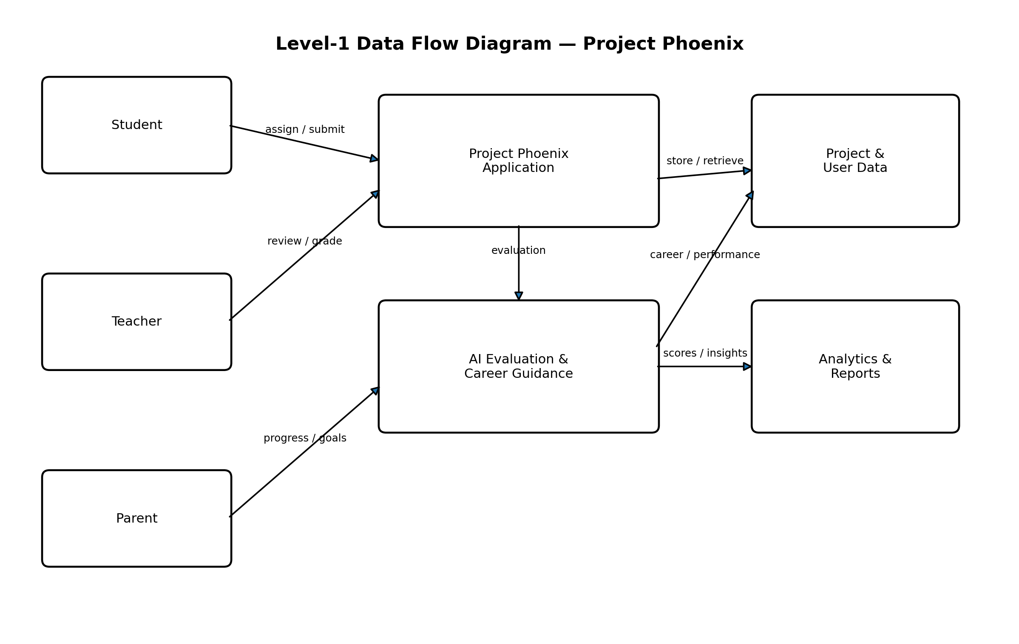
Figure 4. Level-1 Data Flow Diagram of Project Phoenix
8.1 DFD Explanation
• Student → Application: views assignments, submits project work, reviews feedback, and tracks progress.
• Teacher → Application: creates assignments, reviews submissions, enters final marks, and publishes feedback.
• Parent → Application: views linked progress and participates in PTM/career planning.
• Application ↔ Project/User Data: stores and retrieves student, project, assessment, and progress information.
• Application → AI Evaluation & Career Guidance: sends relevant project/skill information for preliminary evaluation and pathway suggestions.
• Analytics & Reports: converts stored assessment data into class insights, charts, performance summaries, and career distributions.

8.2 Detailed System Architecture
Project Phoenix can be understood as a layered academic application. The project presentation and interface reference describe role-specific workspaces connected through a shared project workflow. The layers below are a logical description of the proposed prototype, not a claim that every production service has already been deployed.
Layer | Responsibilities | Typical Information
Presentation | Displays role-specific dashboards, forms, tables, project cards and status indicators. | Assignments, deadlines, progress, review status and notifications.
Application | Coordinates assignment creation, submission handling, evaluation workflow and role-based views. | Project rules, submission state, rubric criteria and feedback.
Data | Stores and retrieves student, project, assessment and progress records. | Student/project records, competency scores, points and career fields.
Analytics | Aggregates records for class insights, charts and performance summaries. | Subject distribution, competency averages, submission rates and career counts.
AI assistance | Provides preliminary completeness, accuracy and rubric-alignment observations. | Draft evaluation notes and improvement suggestions for teacher review.
A layered structure makes responsibilities easier to understand and maintain. The presentation layer focuses on usability, application rules control how records move between assignment, submission, review and publication, analytics summarizes stored records, and AI assistance supports rather than replaces teacher judgement.
The student workspace focuses on completing assigned work and understanding progress.
The teacher workspace focuses on assignment definition, review, grading and class-level insight.
The parent workspace focuses on progress visibility, goals and counselling conversations.
Shared records allow one learning activity to support assessment, portfolio evidence and career exploration.
8.3 Functional Requirements
Functional requirements describe the actions the platform should support. They are organized by user role and shared workflow so that expected behaviour can be checked during development and demonstration.
ID | Requirement | Expected Behaviour
FR-01 | Role-specific access | Students, teachers and parents see the workspace relevant to their role.
FR-02 | Assignment creation | Teachers define title, subject, level, instructions, deadline, accepted files and rubric.
FR-03 | Student submission | Students upload permitted files or provide project links and submit work.
FR-04 | Submission status | Draft, submitted, under review and reviewed states are understandable.
FR-05 | AI preliminary review | AI observations are labelled preliminary and distinguished from final marks.
FR-06 | Teacher grading | Teachers inspect original work, assign rubric scores and add feedback.
FR-07 | Grade publication | Only a teacher-published result is treated as the final reviewed grade.
FR-08 | Student progress | Students see reviewed results, deadlines, points, badges and project evidence.
FR-09 | Career exploration | Students compare interests and demonstrated skills with exploratory pathways.
FR-10 | Parent progress view | Parents see permitted progress information for their linked student.
FR-11 | Class analytics | Teachers view aggregated class indicators and competency distributions.
FR-12 | Portfolio | Students collect teacher-reviewed projects and related skill evidence.
A prototype demonstration should show the complete path: a teacher creates an assignment, a student submits it, a preliminary evaluation appears, the teacher reviews and publishes the result, and the student dashboard reflects the reviewed outcome.
8.4 Non-Functional Requirements
Non-functional requirements describe the qualities expected from the platform. They matter because the application contains academic records, assessment comments and information used in career conversations.
Quality | Requirement and Rationale
Usability | Navigation labels and status messages should be understandable to users with different levels of technical confidence.
Consistency | Similar actions such as viewing a project, checking a deadline and reading feedback should use consistent layouts.
Performance | Dashboards should avoid unnecessary repeated calculations and summarize large tables where practical.
Reliability | Submitted work and published grades should remain associated with the correct student and assignment.
Privacy | Each role should receive only information needed for its responsibilities.
Transparency | AI observations, teacher feedback and final marks should be visibly differentiated.
Maintainability | Modules should have clear responsibilities so project management, evaluation and analytics can be improved separately.
Accessibility | Forms should have clear labels, readable contrast and meaningful status text.
Portability | Accepted submission formats and export options should be stated clearly.
Auditability | Important changes to submissions, marks and publication state should be traceable in a future production version.
These requirements are design goals and evaluation criteria. Their inclusion does not mean that every item has been independently verified in a deployed production environment.
8.5 Use-Case Descriptions
Use Case 1: Teacher Creates an Assignment
Primary actor: Teacher. Preconditions: the teacher has access to the teacher workspace. Main flow: the teacher opens Assignments, enters the project title and subject, specifies instructions and a due date, chooses accepted submission formats, defines rubric criteria, checks the details and publishes the assignment. Expected result: the assignment is available in the relevant student project list.
Use Case 2: Student Submits Project Work
Primary actor: Student. Preconditions: an assignment is available. Main flow: the student opens My Projects, reads requirements, prepares the report or artefacts, uploads permitted files or adds a project link, checks the submission and submits it. Expected result: a submission is associated with the correct assignment and a visible status.
Use Case 3: Teacher Reviews and Publishes a Grade
Primary actor: Teacher. Preconditions: a student submission exists. Main flow: the teacher opens the Evaluation Inbox, reviews the submission and preliminary AI observations, scores the work against the rubric, writes feedback and publishes the final grade. Expected result: the reviewed result becomes available in the student progress view.
Use Case 4: Student Explores Career Pathways
Primary actor: Student. Preconditions: project and skill information is available. Main flow: the student reviews demonstrated skills and stated interests, examines suggested pathways, reads the explanation and identifies skills to practise next. Expected result: exploratory next steps rather than a guaranteed career prediction.
Use Case 5: Parent and Teacher Discuss Progress
Primary actors: Parent and teacher. Preconditions: the parent is linked to the student and relevant progress records are available. Main flow: both parties review project evidence, strengths, improvement areas and goals. Expected result: a more informed counselling conversation based on reviewed work.
These use cases describe the intended workflow and provide scenarios that can be used in a demonstration or future acceptance test.
8.6 Assignment Rubric and Submission Rules
The project concept includes a rubric that makes evaluation criteria visible before work begins. Transparent criteria help students plan submissions and help teachers explain how results were reached.
Rubric Criterion | Weight | What It Examines
Research & Evidence | 30% | Relevant sources, supporting evidence and appropriate references.
Accuracy & Analysis | 30% | Correctness, interpretation of results and depth of analysis.
Creativity & Application | 25% | Originality, practical application and thoughtful problem-solving.
Communication | 15% | Organization, clarity, explanation and presentation.
The concept describes a sample report of approximately 800–1,000 words with cited sources, experiment photographs or materials where relevant, a temperature data table or chart, and a reflection of approximately 100–250 words. Individual teachers may define different requirements for other projects.
Submission Rule | Specification in the Project Concept
Accepted formats | PDF, DOCX, PPTX, JPG and ZIP
Maximum per file | 20 MB
Total submission size | 50 MB
Required components | Report, supporting evidence, data table/chart and reflection when requested
Review sequence | Submission, preliminary AI review, teacher review, final publication
A rubric should be explained in student-friendly language. A high research score should be supported by evidence and citations, while a high communication score should reflect clarity and organization. A numerical score alone is less useful than a score accompanied by criterion-level comments.
8.7 AI-Assisted Evaluation and Human Oversight
The AI-assisted evaluation component provides an initial view of a submission. It may highlight missing components, potential gaps against rubric criteria and possible improvements. It should not replace a teacher’s understanding of learning objectives, classroom context or individual circumstances.
The system receives the submitted project and assignment requirements.
The AI assistance layer checks available evidence against the stated rubric and required components.
The system presents preliminary observations and areas that may need attention.
The teacher checks the original student work and determines whether the observations are appropriate.
The teacher assigns or confirms criterion-level scores, adds feedback and publishes the final result.
The student sees the published grade and feedback, with preliminary AI output clearly distinguished.
The interface reference gives an illustrative case in which the preliminary AI score is 86/100 and the teacher’s score is 88/100 before publication. This example demonstrates why the two values should not be treated as interchangeable. The published teacher result is the final reviewed grade.
Students should understand whether a displayed score is preliminary or final.
Teachers should be able to disagree with an AI observation and record their own assessment.
AI suggestions should be related to assignment requirements and rubric criteria.
Career suggestions should be exploratory and not presented as guaranteed outcomes.
A single automated score should not be the sole basis for important academic decisions.
A future implementation should evaluate AI observations against teacher-reviewed examples, document limitations and provide a process for correcting inaccurate feedback.
8.8 Data Dictionary and Field Interpretation
The cleaned dataset contains 21 columns. The following field groups explain how the data can be interpreted for academic dashboards and career exploration.
Field | Interpretation | Possible Analytical Use
student_id | Student identifier. | Count records and connect project activity to a learner.
student_name | Student name field. | Display or group records where authorized; protect personal information.
age | Age value. | Describe the dataset population in aggregate.
city | City field. | Summarize records by location without assuming city determines ability.
education_level | Education category. | Compare records across education groups.
project_id | Project identifier. | Count unique projects and group records.
project_subject | Project subject/category. | Compare subject distributions and average scores.
skill_level | Beginner, Intermediate or Advanced. | Describe the level assigned to the project record.
programming_score | Programming competency score. | Compare programming with other competency measures.
analytical_score | Analytical competency score. | Review analytical performance patterns.
creativity_score | Creativity competency score. | Review creative application patterns.
communication_score | Communication competency score. | Review communication patterns.
problem_solving_score | Problem-solving competency score. | Review problem-solving patterns.
completeness_score | Completeness measure. | Identify whether submissions include expected components.
accuracy_score | Accuracy measure. | Review correctness-related patterns.
submitted_on_time | Submission timing indicator. | Calculate on-time and late-record proportions.
project_score | Project assessment score. | Summarize overall score distribution.
points_earned | Points associated with project activity. | Summarize gamification-related points.
ai_feedback | Qualitative feedback category. | Count common feedback themes.
career_interest | Recorded career interest. | Compare interest patterns.
recommended_career | Career recommendation field. | Summarize recommendations present in the dataset.
Fields should be interpreted according to their definitions and collection process. A recommended_career value records a recommendation in the dataset; it does not establish that a student has chosen that career or that the recommendation is objectively correct.
8.9 Expanded Dataset Findings
The dataset contains 1,000 student-project records, 21 columns, 100 unique project IDs, 10 project subjects and records from 10 cities. The findings below describe the supplied dataset and should not be generalized to all students without evidence that it is representative.
Measure | Observed Value | Interpretation
Average project score | 69.79 | Mean score across supplied records.
Median project score | 69.8 | Midpoint of the observed score distribution.
Minimum project score | 35.8 | Lowest score in the supplied dataset.
Maximum project score | 96.5 | Highest score in the supplied dataset.
Average points earned | 94.33 | Mean points value across records.
On-time records | 808 / 1,000 (80.8%) | Most records are marked submitted on time.
Not-on-time records | 192 / 1,000 (19.2%) | A smaller but meaningful group is marked not on time.
Intermediate skill level | 458 records | Largest skill-level group.
Beginner skill level | 401 records | Second-largest skill-level group.
Advanced skill level | 141 records | Smallest skill-level group.
Average competency values are programming 57.61, analytical 61.31, creativity 61.68, communication 65.01, problem solving 67.08, completeness 77.30 and accuracy 61.29. Completeness is the highest average measure, while programming is the lowest. This difference can guide further investigation but does not by itself explain why scores differ.
A next analytical step would be to compare competency averages by subject, skill level and submission status, then inspect whether sample sizes are sufficient. Any association should be described as a pattern in the dataset rather than proof that one factor causes another.
8.10 Career Guidance Logic and Interpretation
Project Phoenix connects demonstrated project skills with recorded career interests and recommended careers. The purpose is to help students explore pathways and identify practical next steps. The dataset includes UI/UX Designer, Product Manager, Mobile App Developer, Database Administrator, Data Analyst, Software Developer, Cloud Engineer, Cyber Security Analyst and AI/ML Engineer among its recommendations.
The most frequent recommended careers in the supplied records are UI/UX Designer (277), Product Manager (213), Mobile App Developer (117), Database Administrator (107) and Data Analyst (93). These counts describe the dataset; they do not indicate the number of available jobs in the labour market or prove that a career is best for every student.
Suggested Student-Facing Guidance Flow
Show the student a summary of reviewed projects and demonstrated competencies.
Display recorded career interests separately from system-generated recommendations.
Present exploratory pathways and explain which observed skills or interests relate to each one.
Recommend practical learning activities, such as a small project, a topic to study or a skill to practise.
Encourage discussion with a teacher or counsellor and revision of goals as new evidence appears.
A useful career guidance screen should avoid permanently classifying a student. Skills change with practice and interests can change through exposure to new subjects. Recommendations should therefore remain revisable and their supporting evidence should be understandable.
8.11 Dashboard and Reporting Design
Role-based dashboards reduce the need for users to interpret raw tables. The system presents information relevant to each user’s responsibilities.
Workspace | Important Dashboard Elements | Purpose
Student | Active projects, due dates, progress, reviewed grades, points, badges, feedback and career guidance. | Help students plan work and understand progress.
Teacher | Active assignments, class size, submission counts, pending reviews, evaluation status and class insights. | Help teachers prioritize reviews and identify patterns.
Parent | Progress summary, reviewed work, strengths, goals, pathways and counselling notes. | Support informed learning conversations.
Analytics | Subject distribution, competency averages, score distribution, submission timing and career counts. | Convert the dataset into interpretable summaries.
Dashboard design should prioritize important actions and avoid overwhelming users with every metric at once. For students, deadlines and actionable feedback may be more useful than a large chart. For teachers, pending reviews and class comparisons may be more useful than gamification metrics. For parents, progress summaries and agreed next steps may be more appropriate than technical measures.
Charts should have clear titles, readable labels and a note about the population summarized. When a chart uses the supplied 1,000-record dataset, it should be described as dataset analysis rather than as a representation of every student.
8.12 Testing Strategy and Acceptance Criteria
Testing should check whether the main workflow behaves as expected and whether each role receives the correct information. The scenarios below are proposed acceptance tests, not a claim that all tests have already been executed.
Test ID | Scenario | Expected Result
TC-01 | Teacher creates and publishes an assignment. | Assignment appears in the student workspace with instructions and deadline.
TC-02 | Student submits a permitted file. | Submission is associated with the correct assignment and status changes appropriately.
TC-03 | Student attempts an unsupported file type. | The system communicates permitted formats and prevents or flags the invalid submission.
TC-04 | AI preliminary evaluation is displayed. | It is labelled preliminary and not presented as a final grade.
TC-05 | Teacher changes the preliminary assessment. | Teacher rubric scores and feedback determine the reviewed result.
TC-06 | Teacher publishes the grade. | Published result becomes visible in the student progress view.
TC-07 | Parent opens linked progress. | Only the linked student’s permitted information is shown.
TC-08 | Analytics summarizes the dataset. | Counts and averages correspond to the selected dataset and filters.
TC-09 | Student opens career guidance. | Recommendations appear as exploratory guidance with context.
TC-10 | Portfolio displays reviewed projects. | Portfolio distinguishes reviewed evidence from unreviewed drafts.
A production-ready system would also need security testing, access-control testing, file-upload validation, backup and recovery testing, usability evaluation and privacy review. Results should record test date, test data, actual outcome and any defect found.
8.13 Privacy, Security and Responsible Data Use
The application concept involves student records, submissions, grades, feedback and career-related information. These data should be handled carefully because they may influence students’ understanding of progress and discussions about future goals.
Apply role-based access so students, teachers and parents access only records relevant to their roles.
Use secure authentication and protect sessions against unauthorized access.
Validate uploaded files, enforce size limits and restrict accepted file types.
Use secure transport for data exchanged between browser and application services.
Back up important records and establish a recovery process.
Keep preliminary AI feedback distinct from teacher-published grades.
Explain how data are used for dashboards and recommendations.
Limit unnecessary collection and retention of personal information.
Provide a way to correct inaccurate records and review disputed assessment information.
Avoid treating city, age or education category as a definitive measure of ability.
These points are recommended safeguards. The report does not claim that a formal security audit, privacy certification or production penetration test has been completed. Such activities would be required before deploying a platform with real student records at scale.
8.14 Limitations of the Current Prototype and Dataset
The report describes a project concept, interface references, a cleaned dataset and an academic prototype workflow. Several limitations should be acknowledged so that the results are not overstated.
The dataset contains 1,000 records, but its description does not establish that it is statistically representative of all students.
An association between a skill score and a recommended career does not prove that the recommendation is appropriate for an individual.
The supplied fields do not document the full method used to generate every career recommendation.
AI evaluation can miss context, misunderstand evidence or provide inaccurate suggestions; teacher review remains necessary.
Average values hide variation between individual students and projects.
A project score may not fully capture collaboration, persistence, creativity or growth over time.
Proposed security, audit and testing practices require implementation and verification before production use.
Dashboard accuracy depends on correct cleaning, field definitions and filtering.
These limitations suggest iterative development. Future versions should document data provenance, validate recommendation logic, evaluate AI feedback against teacher judgement and gather feedback from students, teachers and parents.
8.15 Future Enhancements and Development Plan
Future development can improve the project in stages. The priorities follow the central purpose of Project Phoenix: make project work easier to manage, make feedback more useful and connect reviewed learning evidence to career exploration.
Stage | Enhancement | Expected Benefit
Stage 1 | Stabilize assignment creation, submission status, teacher review and grade publication. | Reliable end-to-end academic workflow.
Stage 2 | Improve dashboards, filters, dataset summaries and downloadable reports. | Clearer progress visibility.
Stage 3 | Add portfolio evidence linked to reviewed projects and competencies. | Stronger record of student work and skills.
Stage 4 | Make career recommendations explainable and revisable. | More transparent pathway exploration.
Stage 5 | Add audit trails, access reviews, backups and documented privacy controls. | Better accountability and protection.
Stage 6 | Evaluate the interface with students, teachers and parents. | Usability improvements based on feedback.
Stage 7 | Validate AI observations against teacher-reviewed examples and document errors. | More responsible AI assistance.
The stages are a proposed development plan rather than a confirmed delivery schedule. Priorities should be adjusted according to implementation status, available resources and feedback from the project guide.
8.16 Summary of Extended Technical Discussion
The extended analysis shows how Project Phoenix modules can form a coherent academic workflow. Functional requirements define actions expected from students, teachers and parents. Non-functional requirements describe usability, reliability, privacy and transparency goals. Use cases and acceptance tests provide concrete ways to review the workflow.
The dataset adds a quantitative view of student-project records, including project scores, submission status, competency measures, feedback categories and career recommendations. These figures can support exploratory dashboards, but their interpretation must remain limited to the supplied data. Career recommendations should be explained and revisited as students gain experience.
Most importantly, the proposed system maintains a clear distinction between preliminary AI assistance and final teacher judgement. By combining project management, reviewed feedback, portfolio evidence, analytics and career exploration, Project Phoenix offers a structured foundation for supporting student development while leaving meaningful educational decisions with teachers and students.

9. Output
The Project Phoenix prototype provides different outputs for each role. The UI reference document presents a shared portal shell and role-specific workspaces, while the project presentation defines the functional workflow around project management, evaluation, career exploration, portfolio, and PTM counselling.
Output / Screen | Main Information Displayed
Student Dashboard | Active projects, deadlines, progress, total points, class leaderboard, badges, feedback, and upcoming checkpoints.
My Projects / Submission | Project requirements, files/links, submission status, reflection, and project progress.
Teacher Dashboard | Class overview, active assignments, submission counts, pending reviews, and class-level indicators.
Assignment Creation | Project brief, class/subject, skill level, deadline, requirements, accepted file types, rubric, and publishing checklist.
Evaluation Inbox | Student submission, preliminary AI score, rubric criteria, teacher scores, final feedback, and review status.
Analytics / Class Insights | Project-score distributions, competency comparisons, submission status, subject analysis, and career-related patterns.
Career Guidance | Skill profile, career interests, suggested pathways, explanation of the match, and next skills to develop.
Portfolio / Leaderboard | Teacher-reviewed projects, demonstrated skills, points, badges, class rank, and selected portfolio evidence.
PTM Counselling | Progress summary, strengths, goals, career pathways, and discussion points for parent-teacher meetings.

The UI reference includes examples of a student dashboard with active projects, points, class ranking, badges and feedback, and a teacher evaluation inbox where AI scores are explicitly preliminary and the teacher publishes the final grade.
The proposed output therefore connects raw student/project data to understandable academic views. It also separates AI assistance from teacher authority, which is important for responsible academic evaluation.

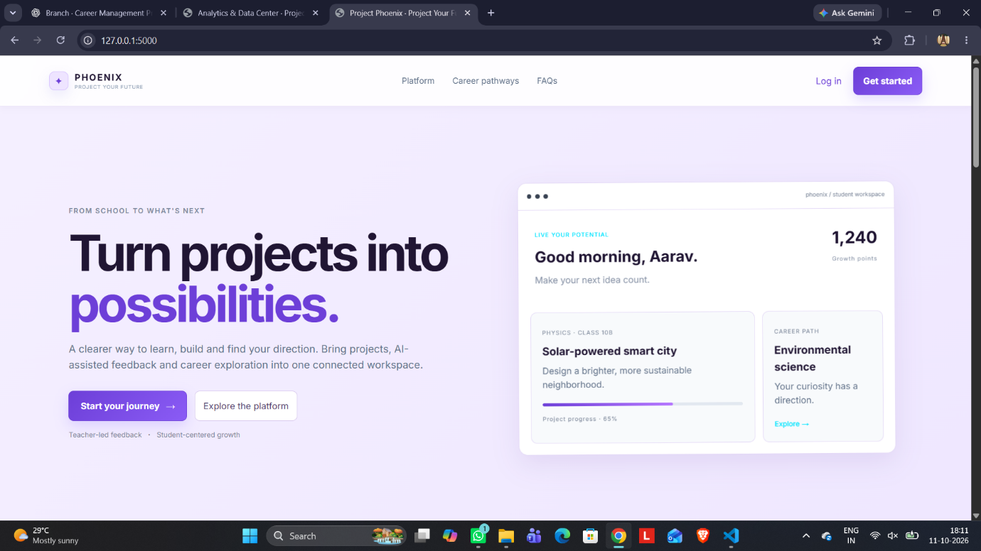

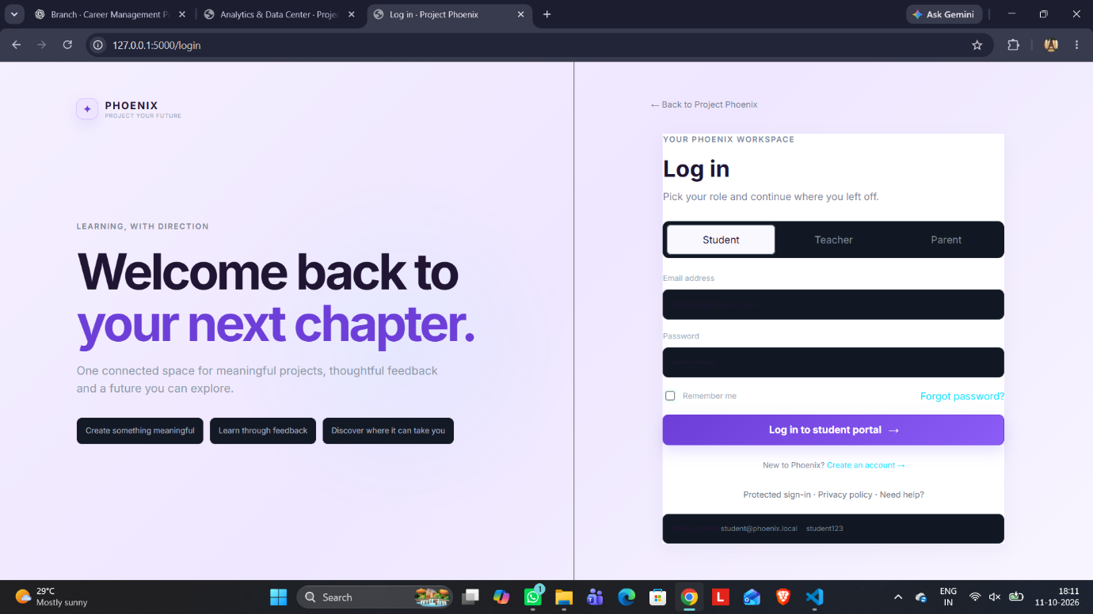

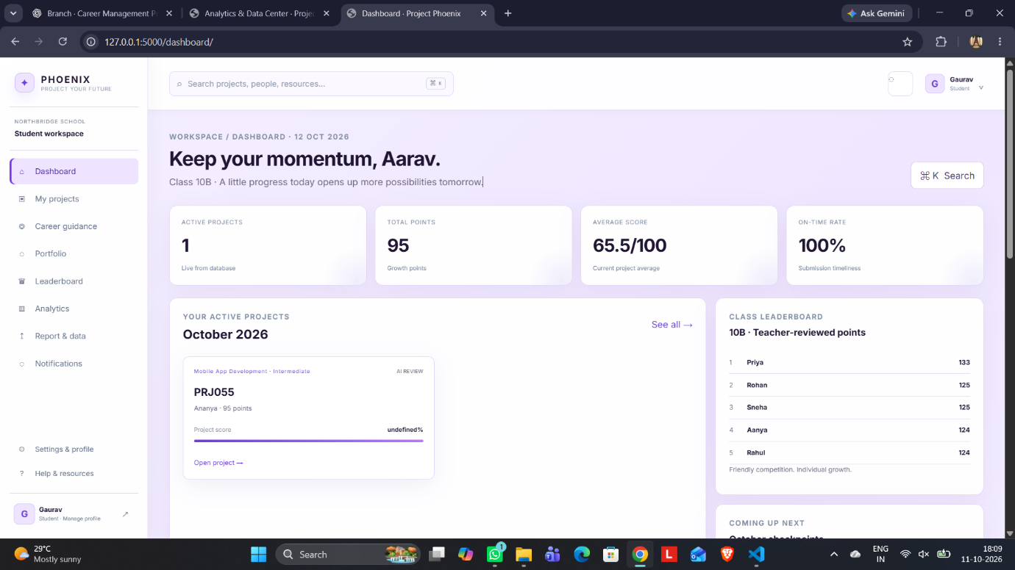

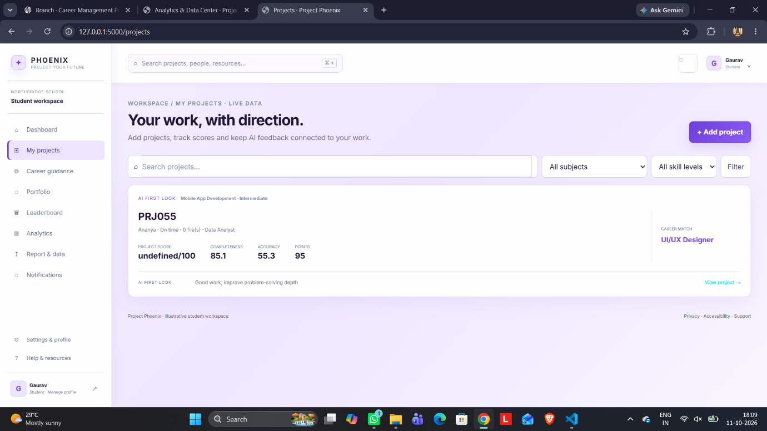

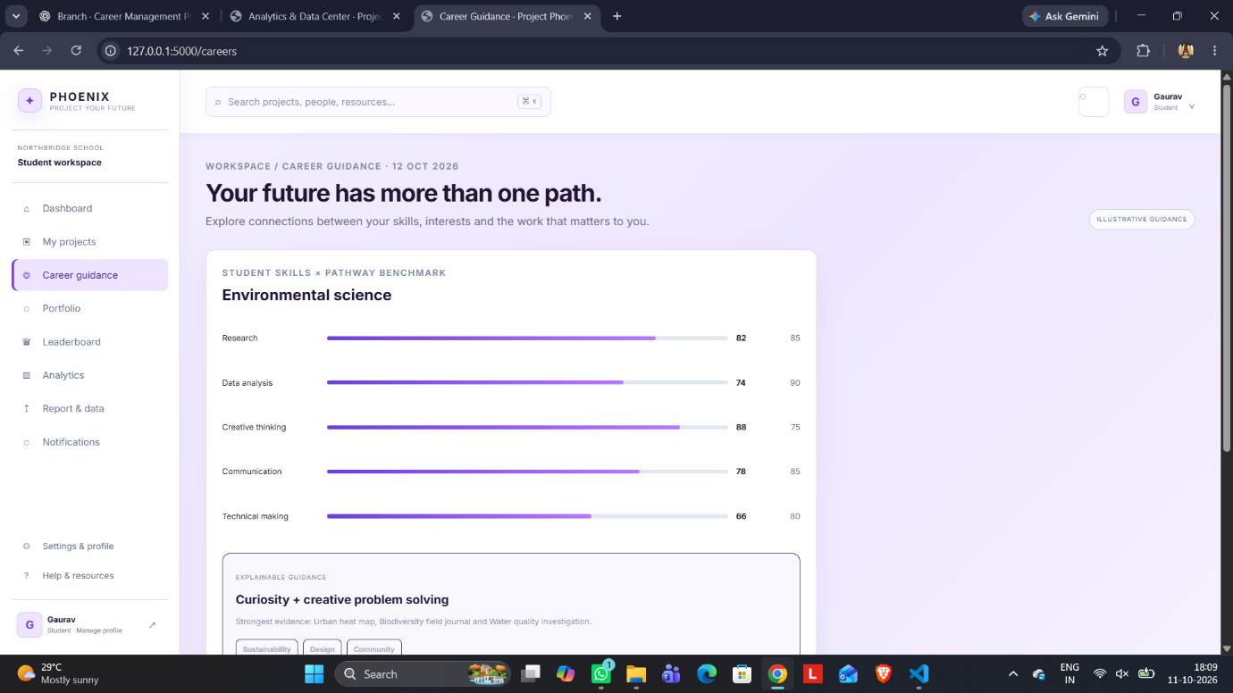

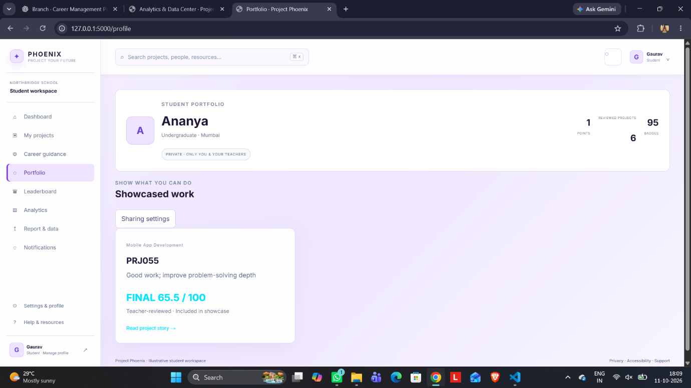

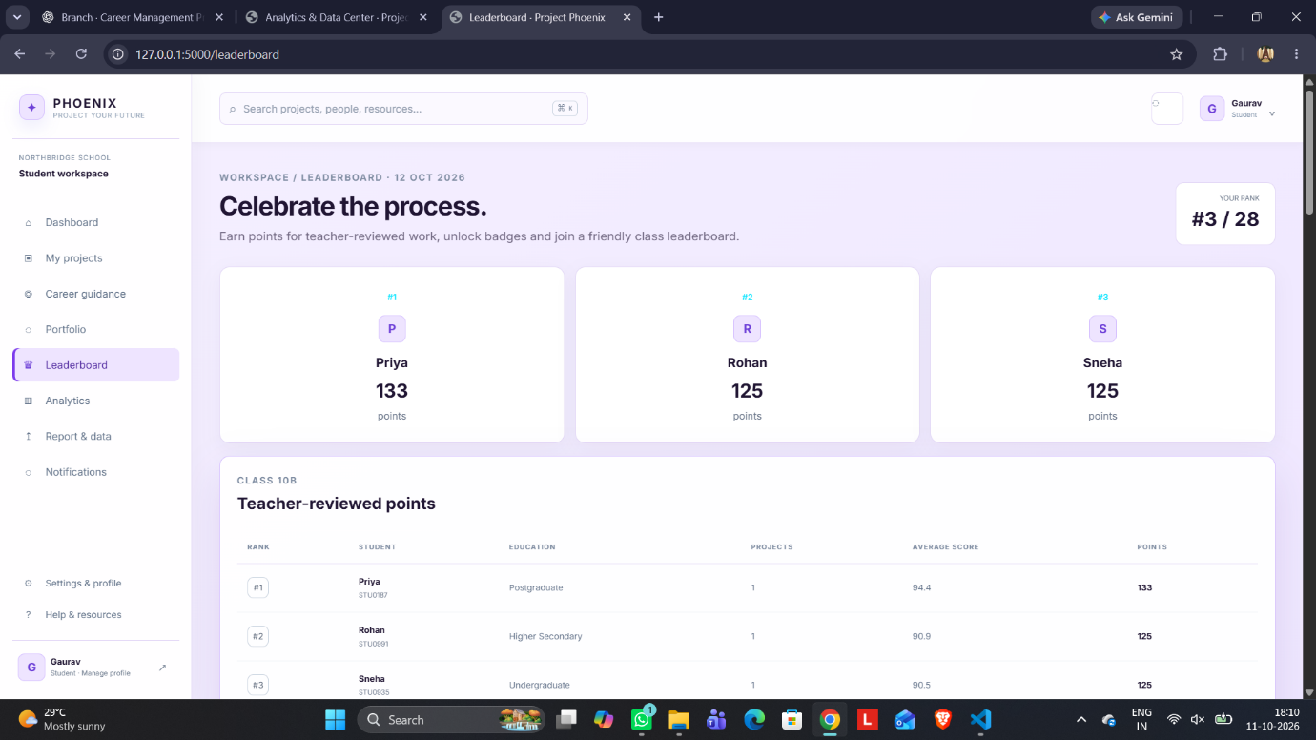

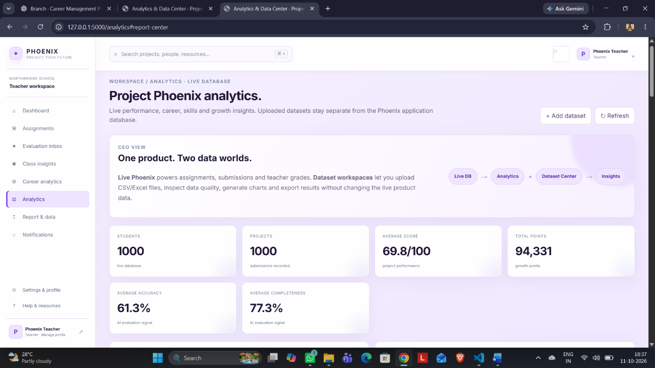

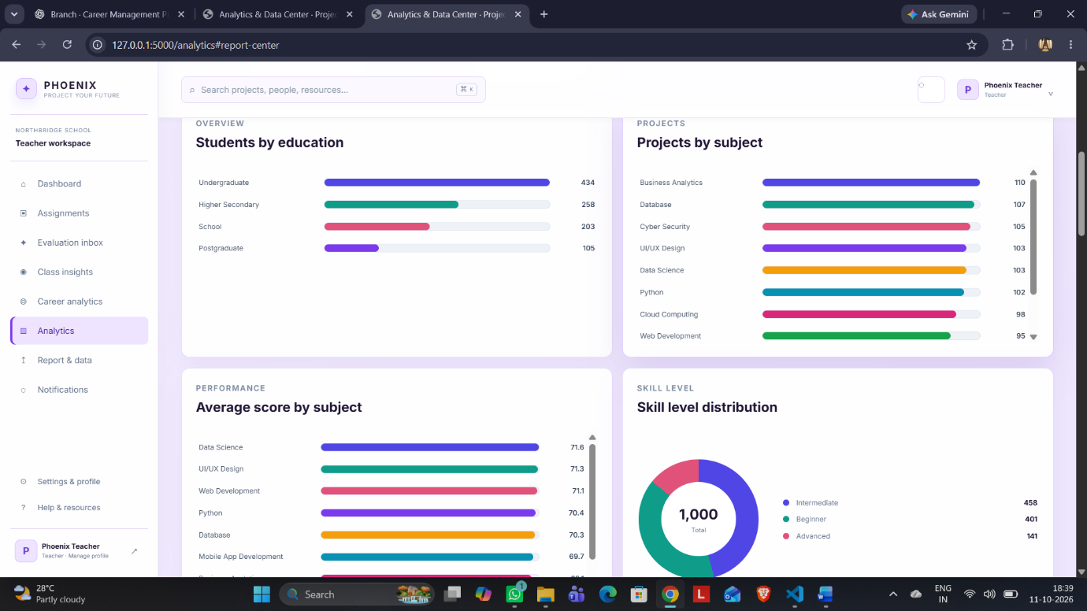

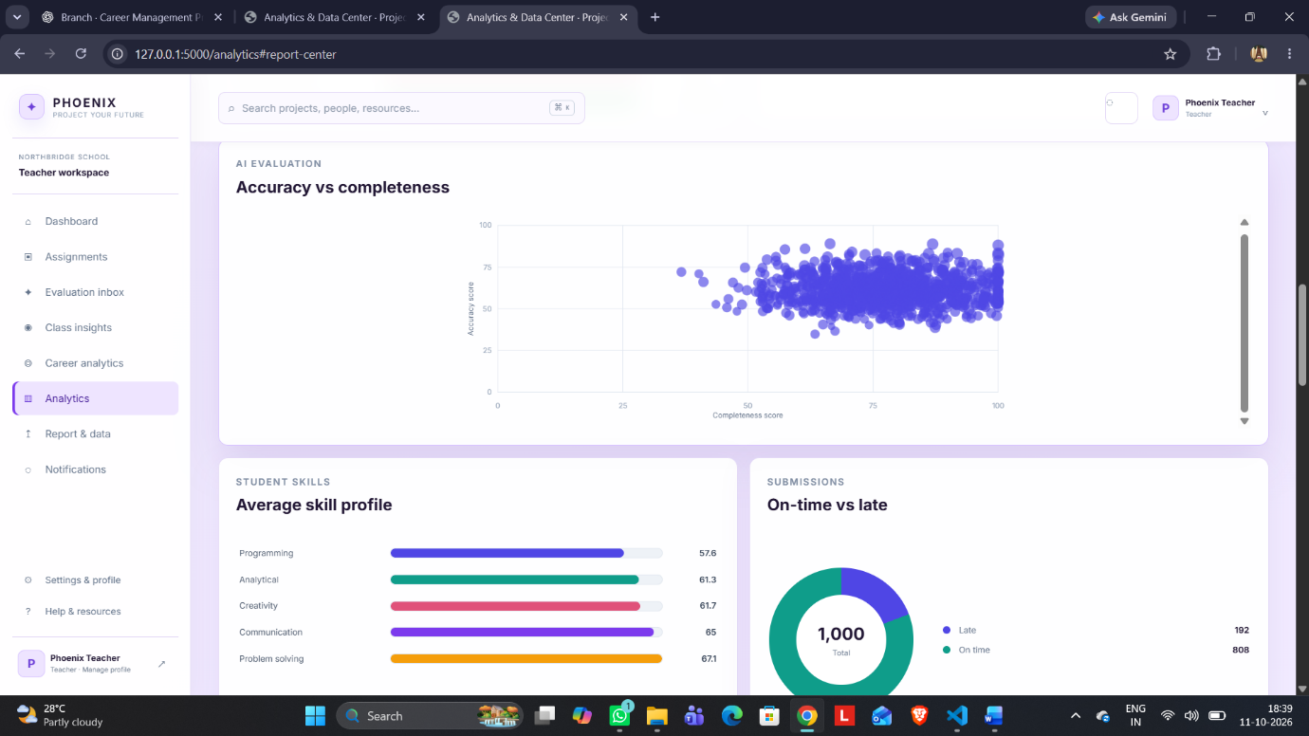

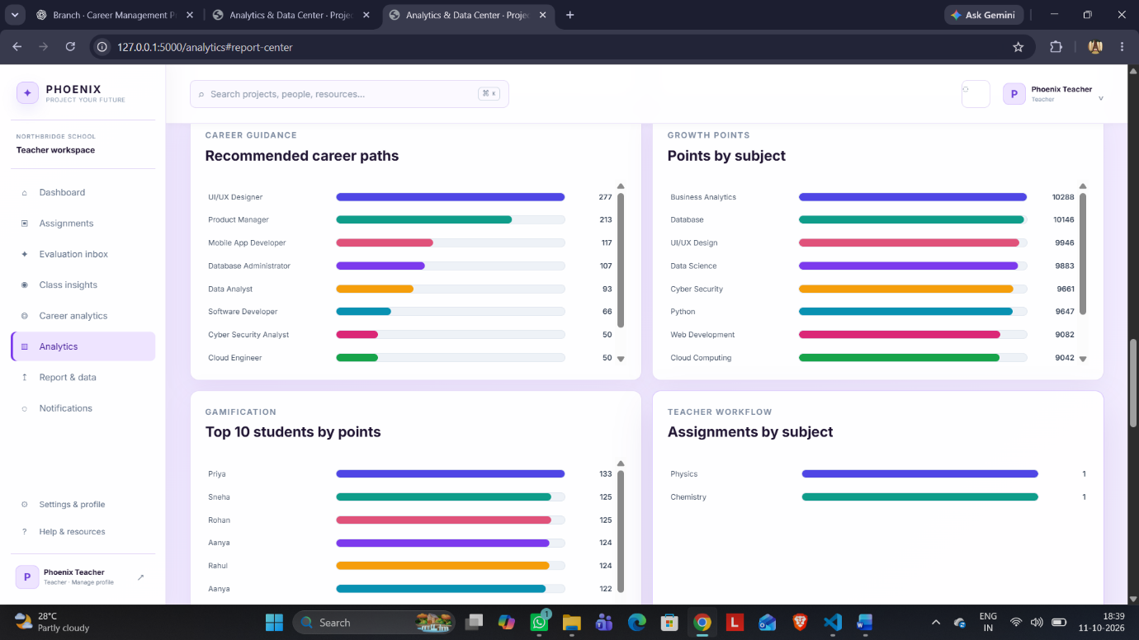

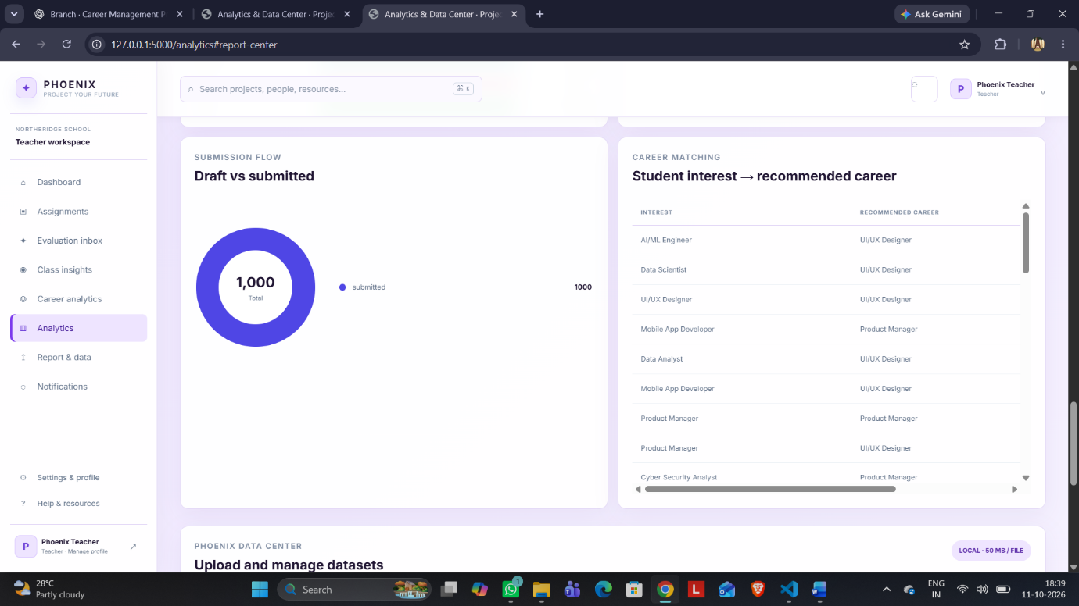

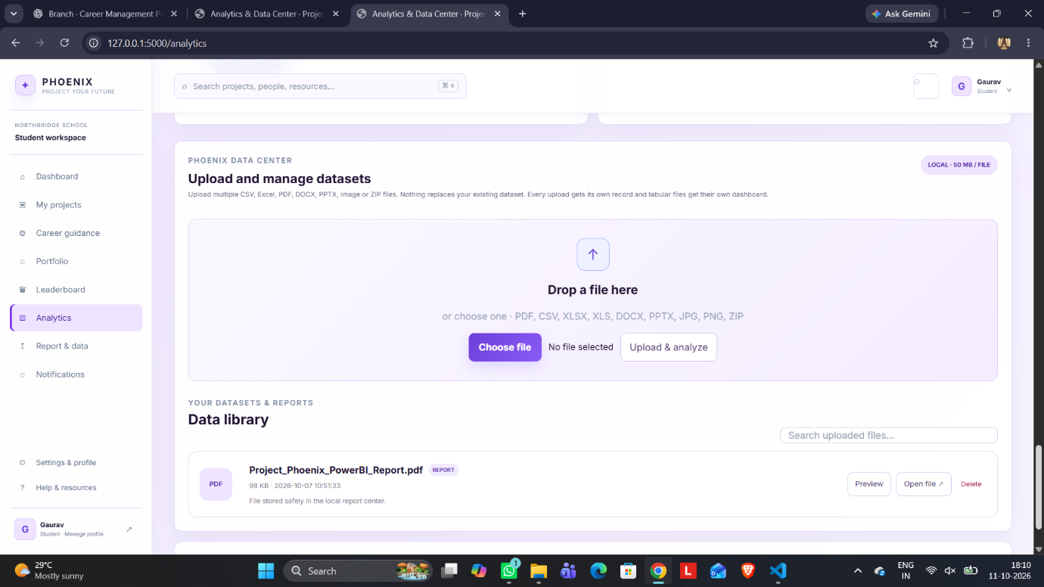

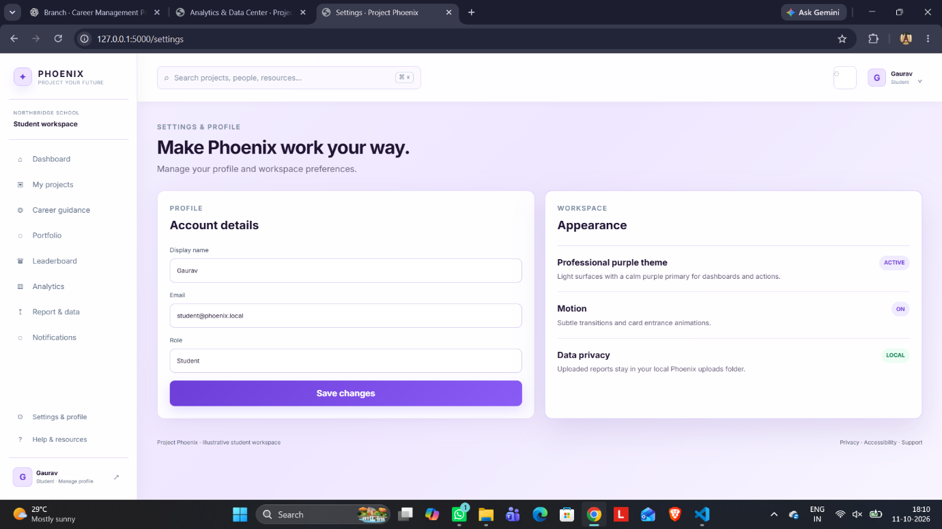

10. Conclusion
Project Phoenix demonstrates how a student project-management platform can be extended into a broader student development system. Instead of limiting the application to assignment submission and marks, the proposed system connects project work with feedback, skill evidence, achievements, analytics, career exploration, portfolio development, and parent-teacher counselling.
The dataset strengthens this approach by providing structured evidence across 1,000 student-project records. It contains project subjects, skill levels, seven competency measures, project scores, points, submission status, AI feedback, career interests, and recommended careers. This makes it suitable for dashboards, class insights, performance analysis, and exploratory career guidance.
The project presentation emphasizes centralized project management, AI-assisted evaluation, career exploration, gamified learning, portfolio development, and PTM counselling. The final system should continue to treat AI as an assistive layer rather than the sole decision-maker: teacher review remains central to final grading, while career recommendations should be interpreted as guidance rather than guaranteed predictions.
Overall, Project Phoenix provides a practical foundation for a unified academic platform in which students can build skills through meaningful projects, teachers can evaluate and guide more effectively, and parents can participate in informed progress and career discussions.

Source Materials Used for This Report
• Alliance University report-format document supplied for this project.
• Project Phoenix project-management presentation supplied for the project.
• Project Phoenix cleaned dataset (project_phoenix_cleaned.csv).
• Project Phoenix UI/reference document supplied for the website design and workflow.

